LAB PROGRAMS

NAME: M.SAI HARSHITHA
REG.NO: 192424408
COURSE CODE: DSA0502
COURSE NAME: QUERY PROCESSING FOR DATASCIENCE

9.Write a Pandas program to create a Pivot table and find the total sale amount region wise, manager wise, sales man wise.
Aim:
To write a Pandas program to create a Pivot Table and find the total sale amount region-wise, manager-wise, and salesman-wise.
Algorithm:
- Import the Pandas library.
- Create a DataFrame containing sales information.
- Save the DataFrame as a CSV file.
- Read the CSV file.
- Display the sales data.
- Create a Pivot Table using Region, Manager, and Salesman.
- Display the total sale amount.
Code:
import pandas as pd
sales = pd.DataFrame({
"Region": ["East", "East", "West", "West", "South"],
"Manager": ["John", "John", "David", "David", "Mary"],
"Salesman": ["A", "B", "A", "B", "C"],
"Sale": [1000, 1200, 900, 1500, 1800]
})
sales.to_csv("sales.csv", index=False)
df = pd.read_csv("sales.csv")
print("Sales Data:")
print(df)
pivot = pd.pivot_table(df,
index=["Region","Manager","Salesman"],
values="Sale",
aggfunc="sum")
print("\nTotal Sale Amount")
print(pivot)
Output:
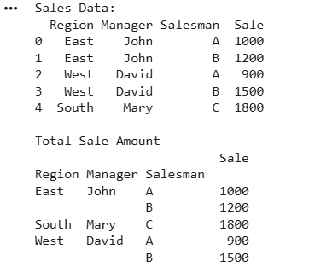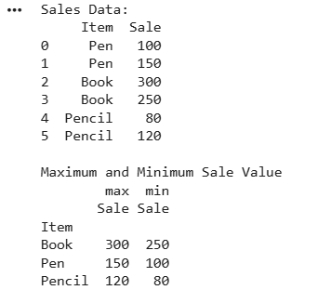

10. Create a dataframe of ten rows, four columns with random values. Write a Pandas program to highlight the negative numbers red and positive numbers black.
Aim:
To create a DataFrame of 10 rows and 4 columns with random values and highlight negative numbers in red and positive numbers in black using Pandas.
Algorithm:
- Import the Pandas and NumPy libraries.
- Create a DataFrame with random values.
- Assign column names to the DataFrame.
- Define a function to set the text color.
- Apply the function to the DataFrame.
- Display the styled DataFrame.
- Stop.
Code:
import pandas as pd
import numpy as np
df = pd.DataFrame(
np.random.randint(-20, 21, size=(10, 4)),
columns=["A", "B", "C", "D"]
)
print("Original DataFrame:")
print(df)
def color(value):
if value < 0:
return "color:red"
else:
return "color:black"
styled_df = df.style.map(color)
styled_df

Output:

